Final Year Project Proposal Report

AI Coding Agent:
An Autonomous LLM Agent for Proactive Code Generation and Reactive Debugging
By:
Maria Sabbagh
Elise Nassar
Raymond Rached
Joe Anthony Daoud

Supervisor(s):
Anthony Assi

A report submitted in partial fulfillment of the requirements for the degree of
COMPUTER AND COMMUNICATIONS ENGINEERING

23/02/2026

Ecole Supérieure d’Ingénieurs de Beyrouth
Université Saint-Joseph de Beyrouth

Contents

List of figures 3
List of tables 5
Acronyms 6
1 Introduction 7
2 Background Research and Related work 8
2.1 Objective of the Market Analysis 8
2.2 Key Comparison Dimensions 8
2.3 Market Comparison Table 8
2.4 How Current Tools Work 9
2.5 Identify Market Gap 11
3 Requirements (Functional and Non-Functional Requirements) 11
3.1 Functional Requirements 11
3.2 Non-Functional Requirements 14
3.3 Conceptual model 16
4 Solution Design 24
4.1 Design alternatives and comparison 24
5 Preliminary implementation 46
6 Conclusion and Future Work Planning : 46
7 References 48

List of figures

Figure 1: AI Coding Agent Workflow 19
Figure 2: Proactive Code Generation Workflow. 31
Figure 3: Code Debugging Workflow. 36
Figure 4: Policy Check and Guardrails Command Validation Workflow. 39
Figure 5: Figure 6 Gantt chart 47

List of tables

Table 1: Market Comparison of AI Coding Tools. 9
Table 2: Non-Functional Requirements. 15
Table 3: Standards, Laws, and Regulations Compliance. 16
Table 4: Workflow Phase Interaction Table. 24
Table 5: Comparative Evaluation of Design Alternatives. 25
Table 6:Local Code Generation Model Comparison. 27

Acronyms

API | Application Programming Interface
AST | Abstract Syntax Tree
CLI | Command-Line Interface
CVE | Common Vulnerabilities and Exposures
FIM | Fill-in-the-Middle
GDPR | General Data Protection Regulation
GoF | Gang of Four
IDE | Integrated Development Environment
LLM | Large Language Model
MoE | Mixture of Experts
NLP | Natural Language Processing
OOP | Object-Oriented Programming
PEP | Python Enhancement Proposal
PyPI | Python Package Index
ReAct | Reasoning and Acting

Introduction

The developer workflow is presently undergoing a paradigm shift due to the advent of Generative AI and Large Language Models (LLMs). Developers are increasingly adopting AI-based tools to write, edit, and debug code. Nevertheless, the present state of affairs is still a split one: developers follow one workflow to develop new code (using prompting on GenAI platforms like ChatGPT or GitHub Copilot) and another, manual workflow to debug the code when it fails on their target host machine. This has resulted in a disjointed experience that hampers development cycles, especially when it comes to routine but time-consuming activities like resolving missing dependencies, correcting syntax errors, and modifying code to work with local system settings.

The objective of this project is to develop a dual-purpose autonomous AI Coding Agent to fill this gap. The agent has two primary purposes. Firstly, it automatically develops executable Python code from high-level natural language specifications (for instance, “develop a Python script to print the latest Microsoft stock price”). Secondly, it automatically debugs existing faulty code or local system dependencies by iteratively running the code, analyzing errors, and applying automated patches until the code successfully executes on the local system without any human intervention.

The present project will cover the entire code development lifecycle from conception to executable functionality. The agent needs to be able to interpret natural language inputs, develop multi-step code implementation plans, recognize and validate necessary libraries, develop code, run it on a sandboxed environment, and autonomously patch any errors that may occur. Moreover, the code debugging mechanism will be designed to be independent and applicable as a separate module to any existing faulty Python code, automating the tedious “copy-paste-error-fix” cycle that developers experience on a daily basis.

The relevance of this project is based on the increasing need for complete autonomy in development tools that run on local machines instead of cloud sandboxes or IDE environments. The current state of the art, as represented by tools like GitHub Copilot, Cursor, and Replit Agent, addresses specific aspects of the development process but lacks a comprehensive, lightweight solution that can automatically generate code, run it on the local machine, and independently debug it to completion. The target audience for this project includes software developers, researchers, and students who require rapid prototyping and automated debugging support for Python projects.

The project is divided into eight phases: Agent Technology Analysis and Project Scoping, Unified System Architecture Definition, Proactive Code Generation implementation, Agent Self-Correction Loop development, Standalone Reactive Debugger formalization, Integration and Evaluation, Code Packaging and Documentation, and Final Deliverables preparation. The project will deliver a functional agent capable of dual-mode operation, an analysis report detailing a comparison of agent design patterns, a final report, and a set of presentations with a pre-recorded demonstration.

The project faces several challenges, including the need to ensure accurate error classification for a wide range of Python errors, avoiding infinite loops during the debugging process, addressing security concerns associated with autonomous code execution, and ensuring that the system maintains acceptable performance levels in terms of latency. These issues are addressed through a series of guardrails that include sandboxed execution, iteration limits, input validation, and logging.

Background Research and Related work

Objective of the Market Analysis
The market analysis summarizes the current landscape of AI coding tools with respect to their ability to generate code, execute it, and debug errors autonomously. The goal is to identify strengths and limitations of existing solutions and highlight the market gap addressed by the proposed AI Coding Agent.

Key Comparison Dimensions
The comparison of existing AI coding tools is performed using the following dimensions:
Code Generation Capability: Ability to generate complete and runnable source code from high-level natural language requirements.
Autonomy Level: Degree of independence, ranging from assistive copilots to fully autonomous agents capable of planning, executing, and iterating without human intervention.
Execution Capability: Ability to run generated or existing code and access execution outputs (stdout, stderr, exit codes).
Debugging Loop: Presence of an execution-driven correction cycle including error detection, classification, automatic fix application, and re-execution.
Environment Realism: Whether execution occurs in cloud, IDE sandbox, or real local machine.
Dependency Handling: Support for detecting and resolving missing libraries and environment issues.
Limitations and Risks: Reliability concerns, security exposure, and operational constraints.

Market Comparison Table
Tool | Code Generation | Autonomy | Execution | Debug Loop | Environment | Dependencies | Limitations
GitHub Copilot (Microsoft) | Strong | Low–Med | Partial | Weak | IDE sandbox | Limited | Human-driven debugging
Codex CLI (OpenAI) | Strong | Low | No | None | Terminal | None | No execution or debugging
Gemini CLI (Google) | Strong | Low–Med | No | Weak | Terminal | Advisory | Manual error copying required
Cursor (Anysphere) | Strong | Med–High | Yes | Medium | Local/IDE | Partial | Reliability varies with task size
Windsurf (Codeium) | Strong | Medium | Partial | Medium | IDE sandbox | Partial | IDE-constrained autonomy
Replit Agent (Replit) | Strong | Medium | Yes (cloud) | Medium | Cloud | Strong | Not local systems
Claude Code (Anthropic) | Strong | Med–High | Yes | Strong | Local term. | Strong | Requires security controls
Gemini Code Assist (Google) | Strong | Medium | Partial | Medium | IDE sandbox | Partial | Ecosystem-dependent
Amazon Q Developer (AWS) | Strong | Med–High | Yes | Medium | Local/IDE | Strong | Safety & permission risks
Devin (Cognition AI) | Strong | High | Yes (sandbox) | Strong | Sandbox | Strong | Limited transparency
Table 1: Market Comparison of AI Coding Tools.
Most tools excel at code generation but fall short on fully autonomous debugging. Debugging often remains human-in-the-loop, especially for dependency and environment errors. Many agents operate in IDE sandboxes or cloud environments, not real local systems. Fully autonomous agents exist, but reliability and control remain open challenges.

How Current Tools Work
GitHub Copilot (Microsoft)
Copilot is mainly a code completion assistant within the IDE, powered by AI. It predicts codes based on comments and context but does not independently execute or debug the code. Execution and debugging are entirely human controlled.
Codex CLI (OpenAI)
Codex CLI is a terminal code generator. It translates natural language commands into code or shell commands. But it does not independently execute the generated code or have a self-correcting loop. Execution and correction are entirely human controlled.

Gemini CLI (Google)
Gemini CLI is a command-line code generator and explainer. It can offer solutions when users copy error messages, but it does not independently execute or work on codes. The debugging process is entirely human-mediated.

Cursor (Anysphere)
Cursor is an IDE-integrated AI development environment that can modify multiple files and assist in debugging. It executes code through the IDE terminal with user approval. While it supports iterative improvements, autonomy is constrained by user interaction and IDE boundaries.

Windsurf (Codeium)
Windsurf operates similarly to Cursor as an AI-enhanced IDE agent. It assists in code generation, refactoring, and limited debugging. Execution happens within the IDE context and typically requires user confirmation for actions.

Replit Agent (Replit)
Replit Agent runs in a cloud-based development environment. It can generate, execute, and modify code within its managed container. However, execution is restricted to Replit’s infrastructure and does not reflect a user’s real local system.

Claude Code (Anthropic)
Claude Code functions as a terminal-level coding agent capable of executing commands and iteratively applying fixes. It operates within controlled environments and requires permission management for security. It supports partial automation of the debug loop.

Gemini Code Assist (Google)
Gemini Code Assist integrates directly into Google-supported IDEs. It assists with generation and suggestions but does not independently control a full execution-debugging lifecycle.

Amazon Q Developer (AWS)
Amazon Q integrates with AWS services and development environments. It supports code generation and cloud-aware debugging but is tightly coupled to AWS infrastructure and permission systems.

Identify Market Gap
The market analysis reveals a clear gap in AI coding tools. Current solutions fall into three categories: (1) Assistive tools (Codex CLI, Gemini CLI) requiring 3+ manual steps per error, (2) IDE agents (Cursor, Windsurf) with 60-70% success in sandboxed environments, (3) Cloud agents (Replit, Devin) operating in isolated containers with significant resource overhead, disconnected from users' local systems.
The proposed AI Coding Agent addresses these gaps through true local operation, complete autonomy with zero manual intervention steps, and a unified dual-mode architecture that handles both code generation and debugging. The system will operate directly on users' actual development environments, handling real dependencies and configurations rather than simulated cloud or IDE contexts.

Requirements (Functional and Non-Functional Requirements)
This section specifies the functional and non-functional requirements for the AI Coding Agent, derived from the project description and informed by the market analysis and risk assessment. Requirements are structured following the ISO/IEC/IEEE 29148:2011 standard for requirements engineering [6].

Functional Requirements
The functional requirements define the core capabilities the system must provide to fulfill its dual-mode operation as both a code generator and a code debugger.
FR-01 — Accept User Task Input
The system shall accept:
- Natural-language programming tasks (Generate Mode)
- File path to a faulty Python script (Debug Mode)

FR-02 — Collect and Use Environment Context
The system shall collect host environment information (OS, Python version, installed packages, filesystem scope, runtime constraints) and use it to constrain decisions.

FR-03 — Process and Structure Observations
The system shall:
- Parse user input
- Parse execution results
- Extract structured observations from errors

FR-04 — Perform Autonomous Reasoning
The system shall:
- Interpret user intent
- Decide between generation or debugging strategy
- Produce a solution strategy using an LLM-based reasoning engine

FR-05 — Generate an Ordered Action Plan
The system shall:
- Decompose strategies into ordered action steps
- Assign appropriate tools to each step
- Manage dependencies between steps

FR-06 — Execute Controlled System Actions
The system shall execute actions including:
- Writing and editing Python files
- Running Python scripts
- Performing controlled filesystem operations
- Installing required packages
All execution must pass through the Guardrails layer.

FR-07 — Enforce Whitelist-Based Command Control
The system shall implement a default-deny security model, where:
- Only explicitly approved commands are allowed
- All other commands are blocked
- Arguments and paths are validated deterministically

FR-08 — Perform Pre-Execution Validation
The system shall:
- Validate Python syntax before execution
- Validate command arguments and filesystem scope
- Reject unsafe operations

FR-09 — Evaluate Execution Results
After each execution, the system shall:
- Capture stdout, stderr, and exit code
- Detect runtime errors
- Determine success or failure

FR-10 — Perform Autonomous Debugging
If execution fails, the system shall:
- Classify error type
- Apply deterministic or LLM-guided fixes
- Modify code or environment
- Re-execute the script

FR-11 — Maintain Iterative Feedback Loop
The system shall implement a closed-loop process:
Plan → Execute → Evaluate → Correct → Re-run
The loop shall continue until success or termination.

FR-12 — Maintain Memory of Attempts
The system shall maintain short-term task memory and track past attempts to avoid repeating failed corrections.

FR-13 — Enforce Iteration Limits
The system shall:
- Track debugging attempts
- Prevent infinite loops
- Terminate after maximum retries

FR-14 — Determine Goal Achievement
The system shall determine task completion when:
- The generated or corrected script executes successfully
- The output satisfies the intended goal

FR-15 — Terminate Safely on Failure
If recovery is not possible, the system shall:
- Halt execution
- Return a structured failure response
- Provide relevant error information

FR-16 — Log All Agent Activity
The system should maintain a comprehensive structured logs including:
- All LLM prompts and responses.
- All commands proposed, validated, and executed.
- All errors detected.
- All actions blocked by the Policy Check with violation reasons.
- Iteration counts and timestamps for each debugging cycle.

FR-17 — Re-route Blocked Actions to Reasoning Engine
When a proposed action is rejected by the Policy Check, the system shall return the violation reason directly to the Reasoning Engine for strategy reformulation, bypassing the Perception module. This shorter feedback loop shall avoid reprocessing original input data that has not changed.

Non-Functional Requirements

Quality attributes and technical constraints
The following non-functional requirements define measurable quality attributes and technical constraints that govern system behavior. These requirements are critical for software design and testing, as functional requirements may be considered met even when non-functional requirements are not, rendering the product unusable.
ID | Category | Requirement
NFR-SEC-01 | Security | The system shall enforce a strict default-deny whitelist model where any non-approved command is blocked.
NFR-SEC-02 | Security | Command validation shall be deterministic and independent from LLM reasoning.
NFR-SEC-03 | Security | File operations shall be restricted to a predefined workspace directory.
NFR-SEC-04 | Security | The system shall prevent command chaining, path traversal, and recursive destructive operations through argument validation.
NFR-SEC-05 | Security | The system shall prohibit arbitrary shell command execution outside the defined whitelist.
NFR-REL-01 | Reliability | The system shall enforce a maximum retry limit to prevent infinite execution loops.
NFR-REL-02 | Reliability | The system shall terminate safely and return structured failure information when recovery is not possible.
NFR-REL-03 | Reliability | The system shall maintain structured logs of execution attempts and detected errors.
NFR-PERF-01 | Performance | Script execution shall be bounded by a predefined timeout.
NFR-PERF-02 | Performance | The system shall limit stdout/stderr size to prevent memory exhaustion.
NFR-PERF-03 | Performance | The agent shall consider host environment constraints during planning and execution.
NFR-DET-01 | Determinism | The security validation layer shall operate independently from the LLM reasoning engine.

Table 2: Non-Functional Requirements.

Standards, laws and regulations
The following standards are applicable to the project’s domain. Each standard is identified with the specific sections implemented and a description of how the solution achieves compliance.

Standard | Section | Title | Compliance Description
PEP 8 | Full | Style Guide for Python Code | All agent source code and generated code follows PEP 8 formatting conventions including indentation, naming, and line length.
PEP 257 | Full | Docstring Conventions | All public functions include docstrings following PEP 257 conventions for documentation.
IEEE 12207 | 6.3.5 | Software Configuration Mgmt | The project uses Git for version control on a private GitHub repository with branch management.
IEEE 12207 | 6.4.11 | Software Validation | A test suite of 10 generation tasks and 10 broken files evaluates agent success rate and reliability.
ISO/IEC 25010 | 4.2.6 | Security | Sandboxed execution, command whitelisting, filesystem restrictions, and input validation protect against security threats.
OWASP | A06:2021 | Vulnerable Components | Library validation checks PyPI for package existence, version compatibility, and known vulnerabilities before installation.
JSON RFC 8259 | Full | Data Interchange Format | All inter-module communication uses JSON-formatted structured data.
RegEx IEEE 1003.1 | Full | Pattern Matching | Regular expressions are used for error message parsing, prompt injection detection, and dangerous code pattern identification.
Table 3: Standards, Laws, and Regulations Compliance.
Regarding data privacy, the system is designed to operate entirely on local infrastructure. When using local LLM models (such as Qwen2.5-Coder), no code or data is transmitted to external servers, mitigating GDPR and data sovereignty concerns. If cloud LLM APIs are optionally used, the system logs this clearly and the user must provide explicit consent.

Conceptual model
The conceptual architecture of the AI Coding Agent is organized around twelve interconnected modules that form an iterative processing pipeline. Two modes of operation are supported in this architecture on a single pipeline. In Generate Mode, the whole pipeline from input parsing through code generation to execution and self-repair is executed. In Debug Mode, the pipeline enters at the execution stage with an existing script, bypassing generation and proceeding directly to the Execute-Analyze-Fix loop. The self-correction loop is the critical bridge that unifies both features into a single coherent system.

High-Level System Architecture
Figure 1: AI Coding Agent Workflow presents the complete AI Agent Workflow, showing all twelve core modules, their interconnections, and the dual feedback loops that enable autonomous operation.
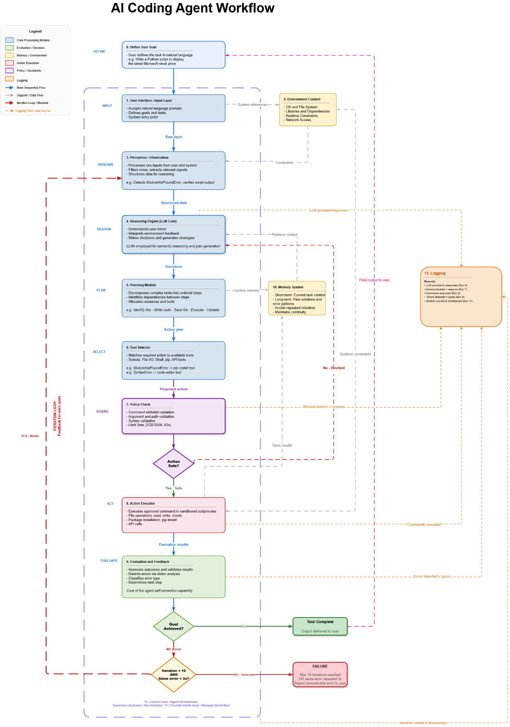
Figure 1: AI Coding Agent Workflow
The architecture consists of the following modules, each performing a distinct function within the autonomous code generation and debugging pipeline:
    - Core Modules and Workflow Description:
Module 0: Define User Goal (Define)

This is the root of the entire system, and it lies beyond the agent pipeline. The user describes, in a high-level natural language form what is needed to be achieved. This is the human intent before any automation. e.g., “Write a Python script to display the latest Microsoft stock price ". The specified goal is directly passed to the User Interface/Input Layer (Box 1) to set up the agent.

Module 1: User Interface/ Input Layer (INPUT)

This is the system’s entry point. It takes in the natural language goal expressed by the user in Box 0 and enters it as a task for the agent pipeline. In Debug Mode, it also accepts a file path to a broken script. The raw input is passed to the Perception module, while simultaneously triggering the Environment Context module to fetch system-level information.

Module 2: Environment Context

This module captures the state of the local machine: installed OS and file system layout, available libraries and dependencies, runtime constraints such as Python version and available memory, and network access status. This information ensures every decision the agent makes is grounded in what the host environment actually supports. It feeds constraints into both the Perception module and the Action Executor.

Module 3: Perception/ Observation (OBSERVE)

The Perception module is responsible for processing all the raw inputs, from both the user and the system, including the execution results from previous iterations. It filters noise, extracts relevant signals, and structures the data for the Reasoning Engine. For instance, if a script has just failed, this module will identify that the error is a ModuleNotFoundError, extracts the missing module name, and packages it as a structured observation. During retry iterations, it also receives execution results from the Evaluation module, closing the feedback loop.
Module 4: Reasoning Engine/ LLM Core (REASON)

The Reasoning Engine is the brain of the agent, powered by a large language model. It interprets user intent, processes environment feedback, makes decisions, and generates strategies. In Generate Mode, it reasons about what code to write and which libraries to use. In Debug Mode, it understands what did go wrong and how to correct it. The Reasoning Engine also retrieves historical context from the Memory System to prevent repeating the same mistake and transmits its decision to the Planning Module.
Importantly, the Reasoning Engine is also the re-entry point when an action is blocked by the Policy Check (Box 7). When the guardrails do not accept a strategy, the violation log is passed back to the Reasoning Engine instead of the Perception module, since the input information has not changed only the strategy needs to be adjusted. This keeps the blocked-action loop shorter and more targeted than the full iteration loop.

Module 5: Planning Module (PLAN)
This module breaks down high-level decisions from the Reasoning Engine into specific, ordered action steps. It also recognizes the dependencies among the steps and assigns the proper tools for each step. A typical generation plan might be: identify required libraries, write the Python file, save to disk, execute the script, and validate the output. A debugging plan might be: run the script, parse the error, install the missing package, and re-run. The Planning Module interacts bidirectionally with the Memory System, updating it with the current plan and retrieving past plans to avoid repeating failed strategies.
Module 6: Tool Selector (SELECT)

The Tool Selector bridges the Planning Module and the execution pipeline. Given the ordered action steps from the planner, it determines which specific tool is relevant to each step and confirms that the tool is available in the current environment. Examples include: routing a ModuleNotFoundError to the pip install tool, or routing a SyntaxError to the code editor tool. The tool and its arguments are then sent to the Policy Check module.

Module 7: Policy Check

The Policy Check module is the security component of the agent, sitting between the action selection and execution phases.
- It intercepts every proposed action and validates it against a set of safety rules before any command is run. The module applies the following checks in sequence: Command whitelist validation: only permitted commands are allowed (e.g. python, pip, ls, cat, mkdir, cp, mv, grep, find). Dangerous commands such as rm -rf, sudo, curl, wget, and ssh are blocked.
- Argument and path validation: shell injection characters (;, |, &&, >, >>) are denied; all file paths must remain within the designated workspace directory; directory traversal (../) and symlink escapes are blocked.
- Syntax validation: the proposed command is checked for syntactic correctness before execution.
- Resource limit pre-check: memory (2GB) and timeout (60s) constraints are verified.
Once validated, a decision point checks for "Action Safe?". If the validation is successful (YES), the validated action is sent to the Action Executor (Module 8). However, if the validation fails (NO), the action is blocked, and a detailed violation log is returned to the Reasoning Engine (Module 4) with the exact rule that was violated, allowing the agent to reformulate its strategy without having to reprocess the original input data. This forms the shorter "blocked action feedback loop."

Module 8: Action Executor (ACT)

The Action Executor is the component that performs concrete actions in the real environment, but only after they have been approved by the Policy Check. It executes out actions using file operations (read, write, create), code execution using subprocess, package installation (pip install), and API calls. Each tool is modular, meaning that they can be combined in any order by the Planning Module. The results are then passed to the Evaluation module and stored in the Memory System.

Module 9: Evaluation and Feedback (EVALUATE)
After every action, this module assesses the outcome. t validates results, detects errors through stderr analysis, classifies error types, and determines the next step. If the script executed successfully with the desired output, it indicates success. If an error occurred, structured feedback is sent back to the Perception module to begin the correction process again. This module is the core of the agent's self-correction capability.
Module 10: Memory System

The Memory System offers both short-term and long-term memory. Short-term memory retains the current task context, including what has been attempted, the current plan, and errors encountered . Long-term memory retains solutions for past tasks and error patterns, allowing the agent to learn from experience and avoid trying the same failing fix repeatedly. It is accessed by the Reasoning Engine, Planning Module, and Action Executor.

Module 11: Control Loop/ Agent Orchestrator

The Agent Orchestrator is the meta-controller that oversees the entire process. It monitors all stages, the number of iterations (maximum of 10 retries) and ensures no infinite loops. It also has the capability to stop the process if the retry threshold is reached, if the same error occurs for the 3rd consecutive time, or if the session times out after 30 minutes. It is represented as a dashed purple border encompassing the entire agent pipeline in the diagram.

Module 12: Logging
The Logging module is a passive observability component that records all significant events across the agent pipeline for post-execution inspection, debugging, auditing, and rollback support. Unlike the Memory System (Box 10), which is bidirectional and actively influences agent decisions, the Logging module is strictly unidirectional, it receives data from other modules but never feeds information back into the pipeline.
The module collects structured log entries from the following sources:
  - Reasoning Engine (Box 4): LLM prompts sent, and responses received, including the reasoning traces and strategy decisions made at each iteration.
  - Policy Check (Box 7): Every action that is blocked by the guardrails, including the specific validation rule that was violated and the rejected command.
  - Action Executor (Box 8): All commands executed in the sandboxed environment, including file operations performed, packages installed, and scripts run.
  - Evaluation and Feedback (Box 9): Errors detected after each execution, including error type classifications, stderr content, and exit codes.
  - Agent Orchestrator (Box 11): Iteration counts, timestamps for each cycle, termination reasons, and session duration.
Each log entry includes a timestamp, the source module identifier, the event type, and the relevant payload data. Logs are retained for 30 days to support post-incident analysis. This module directly satisfies NFR-REL-03 ("The system shall maintain structured logs of execution attempts and detected errors", 3.2) and enables the rollback capability defined in the guardrail framework.
B. The Iteration Loops:
This design outlines two different feedback loops, each with a different point of re-entry:
Loop 1: Goal Not Achieved (Full Iteration Loop):

Upon realizing that the goal has not been met, the error data from the failed process represents new information that must be freshly perceived and structured. The loop will therefore re-enter at Step 3 (Perception), ensuring that the new error message is properly identified and packaged for re-analysis by the Reasoning Engine. This is the main self-correcting loop.

Loop 2: Action Blocked by Guardrails:

Upon rejection by the Policy Check, the input data (user goal and error context) is unchanged. Only the plan needs to be adjusted. The loop will therefore re-enter at Step 4 (Reasoning Engine), skipping the Perception step. This shorter loop enables the agent to quickly think up a new plan without needing to re-evaluate the input data, which is still valid.

A typical full execution cycle proceeds as follows:
- The user sets a goal (Box 0).
- The Input Layer records the task (Box 1).
- The Environment Context is obtained (Box 2).
- The Perception module organizes the input into useful information (Box 3).
- The Reasoning Engine chooses an action plan based on LLM analysis and memory (Box 4).
- The Planning Module outlines the action plan in a series of steps (Box 5).
- The Tool Selector selects the correct tool (Box 6).
- The Policy Check examines the plan of action (Box 7). If denied, go back to Box 4.
- The Action Executor executes the accepted command in a sandboxed environment (Box 8).
- The Evaluation module compares the outcome to the goal (Box 9).
- If the goal is met, the task is finished, and the output is sent to the user.
- If the goal is not met, error messages loop back to the Perception module (Box 3), and the process is repeated with new data.
This loop continues until either the code runs successfully, or the Orchestrator (Box 11) terminates execution due to: reaching the maximum of 10 iterations, the same error recurring 3 consecutive times, or a 30-minute session timeout. The Memory System ensures each iteration is more informed than the last, and the Environment Context keeps every decision grounded in the real constraints of the user’s machine.
Logging throughout the cycle: At each step of the iteration loop, relevant events are recorded by the Logging module (Box 12). This includes the LLM decisions made (Box 4), any actions blocked by guardrails (Box 7), commands executed (Box 8), errors detected (Box 9), and iteration metadata managed by the Orchestrator (Box 11). This provides a complete, timestamped trace of every cycle for post-execution review.
C. Phases Connectivity Summary:
Phase | Receives From | Sends To
0. Define User Goal | User | User Interface / Input Layer
1. User Interface / Input Layer | User (Box 0) | Perception, Environment Context
2. Environment Context | Input Layer | Perception, Reasoning Engine
3. Perception / Observation | Input Layer, Environment, Evaluation | Reasoning Engine
4. Reasoning Engine (LLM Core) | Perception, Memory System, Guardrails (blocked) | Planning Module/ Logging Module
5. Planning Module | Reasoning Engine, Memory System | Tool Selector, Memory System
6. Tool Selector | Planning Module | Policy Check / Guardrails
7. Policy Check / Guardrails | Tool Selector | Action Executor (safe) / Reasoning Engine (blocked) / Logging Module
8. Action Executor | Policy Check (approved) | Evaluation, Memory System, Logging Module
9. Evaluation and Feedback | Action Executor | Goal Check / Perception (loop) / Logging Module
10. Memory System | Planning, Action Executor | Reasoning Engine, Planning Module, Logging Module
11. Agent Orchestrator | All phases (supervisory) | Termination control
12. Logging Module | Reasoning Engine, Policy Check, Action Executor, Evaluation, Orchestrator | None (passive observer, write-only, no pipeline feedback)
Table 4: Workflow Phase Interaction Table.

Solution Design

Design alternatives and comparison

High level alternatives
Alternative A: Standalone CLI Agent with Dual-Mode Architecture (Selected)
- Description: Implements the agent as an independent command-line tool with two operational modes: Generate Mode and Debug Mode. It operates directly on the local Ubuntu system, uses sandboxed subprocess execution for safety, and implements an autonomous self-correction loop.
- Advantages:
  - Full autonomy without IDE dependencies
  - Supports headless operation
  - Direct local system operation
  - Unified solution for both code generation and debugging
  - Lightweight and portable
- Disadvantages:
  - Requires careful security implementation
  - More complex architecture than single-pass systems
- Justification: This design uniquely addresses the market gap identified in the background research: no existing tool provides a lightweight, unified solution that generates code, executes it locally, and autonomously debugs it without human intervention. The CLI-based approach aligns with project constraints and satisfies all functional requirements.
Alternative B: IDE-Integrated Agent Architecture
- Description: Embeds the agent within an IDE (similar to Cursor or Windsurf), leveraging editor context, workspace awareness, and IDE terminal access.
- Advantages: Rich context awareness, seamless integration with development workflow, access to project structure
- Disadvantages: Constrained to IDE sandbox environments, depends on specific editor ecosystems, cannot operate on headless servers or CI/CD pipelines, autonomy limited by IDE permission models
- Verdict: Rejected due to environment.

Alternative C: Monolithic Single-Pass Architecture
- Description: A single LLM call generates code from the prompt, and the output is returned directly to the user without execution or validation. This is the approach used by Codex CLI and Gemini CLI.
- Advantages: Simple to implement, minimal resource requirements, fast response time.
- Disadvantages: No execution capability, no error detection, no self-correction. The user must manually execute, debug, and fix all errors, resulting in a minimum 3-step manual loop per error.
- Verdict: Rejected due to lack of autonomous debugging capability, which is a core requirement.
Comparison Summary:
Criterion | Alternative A:  Standalone CLI Agent with Dual-Mode Architecture  (Selected) | Alternative B:  IDE-Integrated Agent Architecture | Alternative C:  Monolithic Single-Pass Architecture
Autonomy Level | High | Medium | Low
Execution Capability | Full local | IDE-constrained | None
Debugging Loop | Fully automated | Semi-automated | Manual
Environment | Local Ubuntu | IDE sandbox | Terminal only
Meets FR-11, FR-13 | Yes | Partial | No
Meets NFR-03 | Yes | No | No
Complexity | High | Medium | Low
Market Gap Addressed | Yes | Partial | No
Table 5: Comparative Evaluation of Design Alternatives.

Low level alternatives

Local Code Generation Models
A comprehensive evaluation of leading open-source models was conducted to select the best model for local deployment. Four model families were benchmarked: Qwen2.5-Coder, Qwen3-Coder, DeepSeek-Coder, CodeLlama, and StarCoder2.
Model | Developer | Params | Size (fp16) | Context | HumanEval | Released | License
Qwen3-8B | Alibaba (Qwen) | 8.2B | ~16 GB | 128K | ~68% (EvalPlus) | May 2025 | Apache 2.0
Qwen3-Coder 30B | Alibaba (Qwen) | 30B (3.3B active) | ~19 GB | 256K | ~85% | Jul 2025 | Apache 2.0
Qwen2.5-Coder 7B | Alibaba (Qwen) | 7.61B | ~16 GB | 128K | 48–52% | Sep 2024 | Apache 2.0
Qwen2.5-Coder 32B | Alibaba (Qwen) | 32B | ~64 GB | 128K | 65–70% | Nov 2024 | Apache 2.0
DeepSeek-Coder 6.7B | DeepSeek AI | 6.7B | ~14 GB | 16K | 45–48% | Nov 2023 | Commercial
DeepSeek-Coder V2 16B | DeepSeek AI | 16B (2.4B active) | ~8.9 GB | 160K | ~68% | Jun 2024 | MIT
DeepSeek-Coder 33B | DeepSeek AI | 33B | ~66 GB | 16K | ~70% (MBPP) | Nov 2023 | Commercial
CodeLlama 7B | Meta | 7B | ~14 GB | 16K | N/A | Aug 2023 | Llama 2
CodeLlama 34B | Meta | 34B | ~68 GB | 16K | ~48% | Aug 2023 | Llama 2
CodeLlama 70B | Meta | 70B | ~140 GB | 16K | ~67% | Jan 2024 | Llama 2
StarCoder2 3B | BigCode (ServiceNow) | 3B | ~6 GB | 16K | N/A | Feb 2024 | OpenRAIL-M
StarCoder2 7B | BigCode (HuggingFace) | 7B | ~14 GB | 16K | ~35% | Feb 2024 | OpenRAIL-M
StarCoder2 15B | BigCode (NVIDIA) | 15B | ~32 GB | 16K | ~46% | Feb 2024 | OpenRAIL-M
Table 6:Local Code Generation Model Comparison.
What is HumanEval (Pass@1)? HumanEval is a benchmark of 164 hand-crafted Python programming problems created by OpenAI. Each problem provides a function signature and a docstring, and the model must complete the function body. The score (Pass@1) is the percentage of problems the model solves correctly on its first attempt, judged by running unit tests. A higher Pass@1 means the model more reliably writes correct, working code on the first try ,directly relevant to the agent’s Generate Mode.

Qwen3 (Alibaba Cloud)
The newest model in the Qwen family, the Qwen3, was introduced in May 2025. Both dense and Mixture-of-Experts (MoE) architectures are included in the series. 8.2 billion parameters, 36 transformer layers with Grouped Query Attention (GQA), SwiGLU activations, and RoPE positional embeddings are all included in the dense Qwen3-8B model. It can be extended to 128K via YaRN, but it supports 32K context natively. It supports hybrid thinking/non-thinking modes for dynamic reasoning control and was trained on 36 trillion tokens in 119 languages.
Despite being a smaller, general-purpose model, the Qwen3-8B base model outperforms Qwen2.5-14B on coding and STEM benchmarks, achieving ~67.65% on HumanEval+ (0-shot). The Apache 2.0 license, which is completely permissive, is used for its release.
Released in July 2025, the specialized Qwen3-Coder 30B-A3B variant employs a MoE architecture with 30B total parameters but only 3.3B active per token. It is specifically designed for agentic coding tasks with reinforcement learning from environment interaction, supports a 256K native context window (extendable to 1M via YaRN), and achieves ~85% on HumanEval.
Strengths:
Qwen3-8B offers best-in-class performance for a dense 8B model with strong coding capabilities, hybrid thinking mode, and 128K context. The Coder 30B variant offers peak performance with MoE efficiency. Both have permissive Apache 2.0 licenses and support deployment via Ollama.
Hardware:
Qwen3-8B runs on 16–24 GB GPU (fp16) or ~5 GB with 4-bit quantization (Q4_K_M). Qwen3-Coder 30B requires ~19 GB fp16 or ~7 GB with 4-bit quantization.
Qwen2.5-Coder (Alibaba Cloud)
Trained on 5.5 trillion tokens across 92 programming languages. The architecture uses RoPE, SwiGLU, RMSNorm, and grouped-query attention. The 7B variant offers a 128K token context window (expandable via YaRN from a 32K base), making it ideal for reasoning over entire files. The 32B variant matches GPT-4o-level performance. Both are released under the fully permissive Apache 2.0 license.
Strengths:
Best context window (128K), strong multi-language support, permissive license, supports fill-in-the-middle. Mature and well-tested with extensive community adoption.
Hardware:
7B runs on 24 GB GPU (fp16) or 8 GB with 4-bit quantization. 32B requires an A100-class GPU (~80 GB).

DeepSeek-Coder (DeepSeek AI)
Originally trained with repository-level, dependency-aware file concatenation on 2 trillion tokens. The V2 variant introduced a Mixture-of-Experts (MoE) architecture: 16B total parameters but only 2.4B active at inference, making it extremely efficient. The V2 also extends the context window to 160K tokens and achieves GPT-4 Turbo–comparable performance.
Strengths:
V2 is the most memory-efficient high-performer (~8.9 GB); 6.7B matches CodeLlama 13B despite being half the size.
Hardware:
6.7B fits on a single RTX 4090 (16 GB). V2 runs on ~16–24 GB GPU.

CodeLlama (Meta)
Built on the Llama 2 foundation and trained on 500 billion code tokens (85% GitHub, 8% documentation, 7% general text). Available in Base, Python-specialized, and Instruct variants across 7B, 13B, 34B, and 70B sizes. Supports 16K context natively, extendable to 100K with modifications.
Strengths:
Mature ecosystem, broad community, Python-specific variants. The 70B model scores ~67% HumanEval.
Hardware:
Newer models outperform it at the same size. 34B+ variants require high-end GPUs (48–80 GB+). Llama 2 license has revenue restrictions for large companies.
StartCoder2 (BigCode-ServiceNow, Hugging Face, NVIDIA)
Trained on The Stack v2, the largest open-source code dataset. The 15B variant covers 600+ programming languages and was trained on 4.3 trillion tokens. Uses grouped-query attention and fill-in-the-middle training. All training data is documented with Software Heritage persistent identifiers for full transparency.
Strengths: Best data transparency; the 3B variant outperforms the original StarCoder 15B. Ideal for research and ethical AI compliance.
Limitation: Lower HumanEval scores than Qwen or DeepSeek at equivalent sizes. 16K context window with 4K sliding window attention limits full-file reasoning.

Performance Tiers
Tier | Models | Notes
Tier 1 (Best) | Qwen3-Coder 30B, Qwen2.5-Coder 32B, DeepSeek-Coder V2 16B | Match GPT-4o / GPT-4 Turbo level. Require high-end hardware or MoE efficiency.
Tier 2 (Excellent) | Qwen3-8B, Qwen2.5-Coder 7B, DeepSeek-Coder 33B, CodeLlama 34B/70B, StarCoder2 15B | Strong performers. Qwen3-8B is the sweet spot for limited GPU budgets.
Tier 3 (Good) | DeepSeek-Coder 6.7B, CodeLlama 13B, StarCoder2 7B | Solid for simpler tasks. Good fallback options.
Tier 4 (Lightweight) | StarCoder2 3B, Qwen2.5-Coder 3B, CodeLlama 7B | Resource-constrained environments. Can run on laptops.

Choice For the Project

Primary Model: Qwen3-8B
Qwen3-8B is the primary model choice This model was released in May 2025. It is a dense 8.2B parameter model and reaches ~67.65% on HumanEval+ (0-shot), which is a major improvement over the previous Qwen2.5-Coder 7B (48-52%) and comparable to models with almost twice as many parameters. It has a 128K token context window (via YaRN), which allows the model to reason about full files by considering entire Python scripts.
As a dense model (not MoE), Qwen3-8B offers more predictable and stable inference behavior compared to MoE architectures, which is advantageous for a production agent that must generate and debug code reliably. Its hybrid thinking/non-thinking mode allows the agent to engage step-by-step reasoning for complex code generation while using rapid responses for simpler tasks.
With a size of approximately 16 GB in fp16 or 5 GB in 4-bit quantization (Q4_K_M), it is well within the 16-24 GB hardware budget. The model is released under Apache 2.0 and can be run locally with Ollama, which provides complete data isolation.
Fallback Model: Qwen2.5-Coder 7B
Qwen2.5-Coder 7B is designated as the fallback. It is a mature, well-tested, dedicated code model with a 128K context window, solid HumanEval performance (48–52% Pass@1), and the same Apache 2.0 license. As a purpose-built coding model with extensive community validation and proven stability, it is the safer choice if Qwen3-8B presents any deployment or compatibility issues on the target hardware.

Quantization & Deployment
All models can be reduced in memory via quantization. 4-bit quantization cuts memory by ~75% with only 2–5% performance loss (e.g., Qwen3-8B drops from ~16 GB to ~5 GB in Q4_K_M format). Deployment is handled through Ollama, which provides simple CLI-based model management, automatic quantization, and cross-platform support.

Choice Conclusion
Four open-source model families were evaluated for the AI Coding Agent: Qwen, DeepSeek AI, Meta (CodeLlama), and BigCode (StarCoder2). They were compared based on three main requirements: running locally on a 16–24 GB GPU, supporting large context windows, and having a permissive license.
The selected primary model is Qwen3-8B. It offers excellent coding performance (~67.65% HumanEval+), a large context window (128K via YaRN), hybrid thinking modes for dynamic reasoning, and efficient memory usage as a dense 8.2B model. With 4-bit quantization, it runs comfortably within the project’s hardware limits at approximately 5 GB. It is released under the Apache 2.0 license and can be deployed locally using Ollama.
The fallback model is Qwen2.5-Coder 7B. It is a dedicated code model that is more mature, well-tested, and stable, with good performance and a 128K context window. It serves as a safe alternative if any issues arise with Qwen3-8B.
Although CodeLlama and StarCoder2 were not selected, they remain useful in specific cases.
Overall, using Qwen3-8B with 4-bit quantization makes the AI Coding Agent practical, private, and fully deployable on the available local hardware.

Solution modeling
The selected solution implements an twelve-module pipeline architecture supporting dual-mode operation through shared infrastructure. The architecture is illustrated in Figure 1: AI Coding Agent Workflow.

Proactive Code Generation Workflow (Generation Mode)

The Proactive Code Generation Workflow that is illustrated in Figure 2: Proactive Code Generation Workflow. is a multi-stage pipeline that autonomously transforms natural language requirements into executable Python code. The system operates as a deterministic processing chain where each stage performs distinct validation and transformation operations, feeding structured outputs into downstream consumers.
The fundamental principle is progressive enrichment: each phase adds structural information and validation constraints that guide subsequent phases toward reliable code generation. The system prioritizes safety and correctness over feature completeness, enforcing strict validation gates that prevent syntactically invalid or semantically dangerous code from reaching execution.
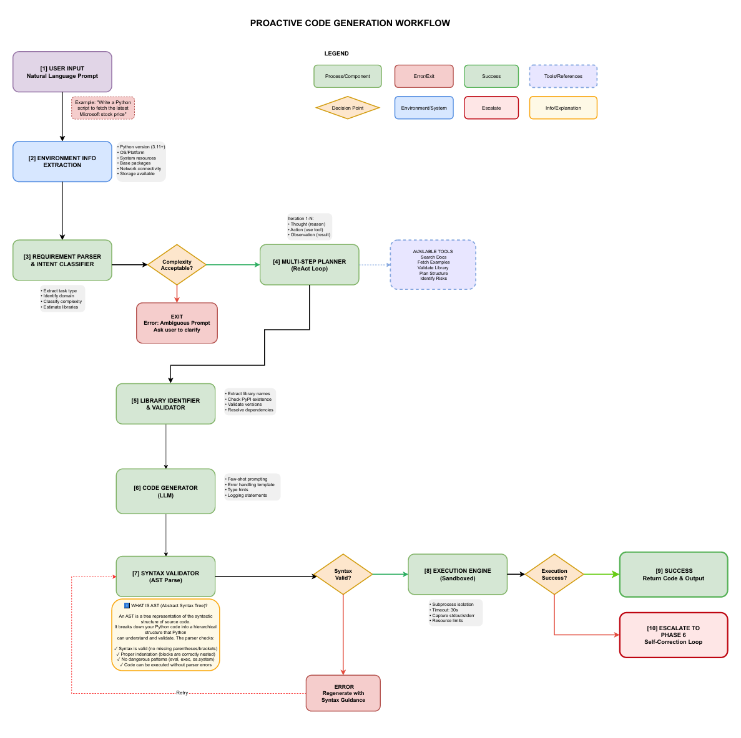
Figure 2: Proactive Code Generation Workflow.

PHASE 1: USER INPUT
The workflow entry point captures natural language prompts without interpretation, filtering, or validation. The user provides an unstructured textual requirement describing the desired code functionality. This phase operates as a pure data collection mechanism—the raw prompt is passed verbatim to downstream processing with timestamp and metadata attached for traceability.
PHASE 2: ENVIRONMENT INFORMATION EXTRACTION
Prior to code generation, the system detects and catalogs target environment characteristics that constrain what code can be generated and executed. This phase extracts Python version, operating system and architecture (affecting library availability and system calls), available system resources, pre-installed packages, network connectivity (determining API availability), and file system permissions.
The extracted environment profile serves as a constraint document for downstream phases. Code generation incorporates these constraints directly avoiding type hints if Python version is pre-3.9, skipping network-dependent code if connectivity is unavailable, selecting data structures appropriate for available RAM. This phase eliminates a major class of execution failures by making environmental constraints explicit before code synthesis.
PHASE 3: REQUIREMENT PARSER & INTENT CLASSIFIER
The parser converts unstructured natural language into a structured requirement specification through a pipeline of NLP operations. Tokenization and part-of-speech tagging identify syntactic structure, while named entity recognition extracts domain-specific entities (company names, file paths, API endpoints). Intent detection maps keywords to operation categories—fetch (data retrieval), compute (processing), visualize (output formatting), analyze (statistical/ML operations). Domain classification determines the problem domain (finance, data science, web services, computer vision) by analyzing keywords and contextual patterns.
Complexity assessment applies a weighted scoring rubric considering operation count, library diversity, and error handling requirements. The system classifies tasks as simple (1-3 operations, 1-2 libraries), medium (4-6 operations, 3-5 libraries), or complex (7+ operations, 6+ libraries). Library estimation predicts necessary dependencies based on identified operations and domain, generating confidence scores for each prediction. The output structure includes task type, domain classification, identified requirements, complexity level, estimated libraries, and a confidence score reflecting classification certainty. Ambiguity detection flags contradictory or underspecified requirements, enabling early rejection of infeasible prompts.
DECISION POINT 1: COMPLEXITY ACCEPTABILITY
The first decision gate evaluates whether parsed requirements fall within the system's supported scope. Complex tasks exceeding acceptable operation counts or those with detected ambiguities trigger rejection, returning to the user with clarification requests. Medium and simple tasks proceed to planning. This gate prevents wasted computation on infeasible tasks and maintains system reliability by refusing requests beyond current architectural boundaries.
PHASE 4: MULTI-STEP PLANNER (REACT LOOP)
The planner decomposes requirements into detailed implementation steps using the ReAct (Reasoning and Acting) pattern, which alternates between reasoning about what is needed and acting by invoking tools to gather information. Each iteration consists of a thought phase (formulating what step is required), an action phase (selecting and invoking a specific tool), and an observation phase (processing tool results to refine understanding).
Available tools include document search for library documentation and tutorials, code example retrieval from GitHub and Stack Overflow, library validation against PyPI metadata, architecture planning for code structure design, and risk identification for flagging potential failure points. The planner outputs a structured plan containing sequential implementation steps, key architectural decisions (library choice, error handling strategy, output formatting), identified libraries confirmed as necessary, flagged error-prone areas requiring defensive programming, and an iteration count demonstrating planning efficiency. This planning phase grounds reasoning in actual library documentation and code examples, substantially reducing LLM hallucination compared to direct code generation.
PHASE 5: LIBRARY IDENTIFIER & VALIDATOR
This phase ensures all identified dependencies are legitimate, safe, and compatible with the target environment. Library name extraction from the plan identifies required packages, which are then normalized against a mapping table to resolve common aliases (PIL → Pillow, cv2 → opencv-python). PyPI queries retrieve authoritative metadata including latest version, author, download statistics, and Python version requirements.
Version resolution selects the most appropriate version for the target environment, checking Python compatibility and filtering pre-release versions unless explicitly specified. Security vulnerability checks query CVE databases and the Safety.io API, blocking installation of any version with known critical vulnerabilities. Transitive dependency chain resolution ensures all recursive dependencies are available and compatible, using constraint solving to detect conflicts. Dry-run installation verification tests whether pip can successfully resolve and prepare packages without executing installation.
The validation output designates each library as approved, deprecated, or unsafe, with detailed justification. Installation plan generation produces pip commands sufficient to fetch all dependencies. Any incompatible library, missing transitive dependency, or critical vulnerability causes the phase to reject the requirement, escalating back to the user for alternative specifications.
PHASE 6: CODE GENERATOR (LLM)
Code generation invokes a large language model (GPT-4 or equivalent) with a carefully engineered prompt assembling requirements, plan, validated libraries, environmental constraints, and few-shot examples. The prompt incorporates explicit quality guidelines requiring comprehensive error handling, logging statements, type hints, docstrings, meaningful error messages, appropriate timeouts, PEP 8 compliance, and absence of hardcoded credentials.
Few-shot learning provides 2-3 reference implementations demonstrating the expected code style and quality level. Chain-of-thought reasoning prompts the LLM to articulate its approach before generating code, improving reasoning coherence. Temperature is set to 0.7, balancing creativity and determinism. Maximum output tokens are limited to 4096, with stop sequences preventing overgeneration.
The generated code typically includes imports organized at module top, function definitions with docstrings and type hints, comprehensive try/except error handling for I/O and network operations, logging configuration and strategic log statements, and a main guard protecting entry point logic. Quality assurance checks post-generation verify import statements reference only validated libraries, type hints appear on ≥80% of functions, docstrings are present on ≥80% of functions, error handling covers ≥1 exception per function, and no dangerous constructs (eval, exec, os.system) exist.
PHASE 7: SYNTAX VALIDATOR (AST PARSE)
Syntax validation uses Python's Abstract Syntax Tree parser to verify code is syntactically correct before execution. The AST represents code as a hierarchical tree structure, enabling structural analysis. The parser catches syntax errors (missing colons, unbalanced parentheses), indentation errors (misaligned block structure), and other parse-time failures. Beyond syntax, safety pattern detection applies regex matching to identify dangerous constructs including eval(), exec(), import(), subprocess calls with shell=True, and os.system() invocations. All dangerous patterns cause validation failure.
Structure validation counts bracket and parenthesis pairs, detecting mismatches. AST visitor traversal implements best-practice checks: functions lack docstrings, functions lacking return type hints despite returning values, and imports restricted to validated libraries only. These checks are warnings rather than failures, logged for developer awareness but not blocking progression. The validation result includes a boolean pass/fail determination and detailed issue lists enabling code regeneration with corrected guidance.
DECISION POINT 2: SYNTAX VALIDITY
If syntax validation fails, the system triggers code regeneration, routing back to Phase 6 with enhanced prompt guidance specifically addressing detected syntax errors. This retry loop continues until code validates successfully or iteration limits are exceeded. Successful validation permits progression to execution.
PHASE 8: EXECUTION ENGINE (SANDBOXED)
The execution engine runs generated code in an isolated subprocess with strict resource constraints and timeout protection. Code is written to a temporary file in an isolated directory, executed via subprocess.run() with stdout/stderr capture, 30-second timeout (configurable), and environment variables sanitized to exclude sensitive data. Resource limits include memory constraints (typically 512MB) and CPU restrictions using cgroups in container environments.
The execution engine returns structured results including return code, stdout content, stderr content, and execution time. Successful execution (return code 0) with no stderr output is classified as success. Any non-zero return code or stderr output triggers failure classification. The timeout mechanism kills processes exceeding wall-clock limits, capturing that condition as a distinct failure reason.
DECISION POINT 3: EXECUTION SUCCESS
Upon successful execution (return code 0, minimal stderr), the system returns generated code and output to the user as Phase 9 (Success). Execution failures (ImportError, runtime exception, timeout) escalate to Phase 10 (Escalate to Self-Correction Loop), which implements error analysis and automated correction strategies beyond Phase 1 scope. Error classification identifies error type (ImportError for missing packages, RuntimeError for logic bugs, TimeoutError for hanging code, API errors for external service failures) and suggests appropriate remediation.

Code Debugging Workflow (Debug Mode)
The Debug Mode workflow illustrated in Figure 3: Code Debugging Workflow. implements an error-driven iterative correction loop:
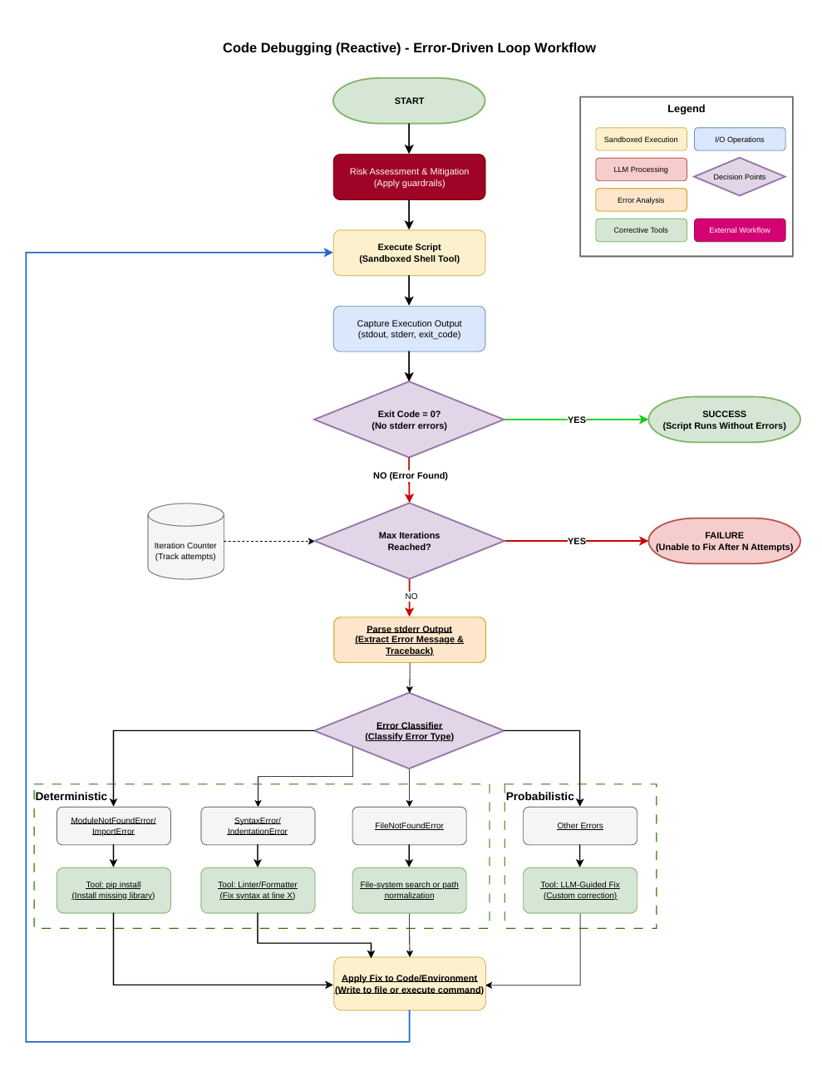
Figure 3: Code Debugging Workflow.

Step 1 Risk Assessment and Mitigation
Before any code is executed, the agent applies the guardrail framework. This includes verifying that the target script path resides within the designated workspace directory, checking container isolation status, and enforcing permission controls.
Step 2 Execute Script (Sandboxed)
The script is executed in a sandboxed shell with subprocess isolation, a 60-second timeout, and resource limits. stdout, stderr, and the exit code are captured.
Step 3 Check Exit Code
If exit code is 0 and no stderr errors are present, the script is declared successful and the process terminates.
Step 4 Iteration Control
If maximum iterations (10) reached or same error recurred 3+ times, the agent declares failure. Otherwise, the loop proceeds to error parsing.
Step 5 Parse stderr Output
The error message and traceback are extracted from stderr for analysis.
Step 6 Error Classifier (Hybrid)
Deterministic branch handles known patterns: ModuleNotFoundError/ImportError triggers pip install; SyntaxError/IndentationError triggers the Linter/Formatter; FileNotFoundError triggers file-system search or path normalization. Probabilistic branch routes unrecognized errors to LLM-guided custom correction.
Steps 7–8 Apply Fix and Loop Back
The corrective action is applied, then the loop returns to Step 2 to re-execute the corrected code.

Risk Assessment and Mitigation
Risk of Executing LLM-Generated Code Locally
Executing LLM-generated code directly on a host machine introduces significant security risks. Unlike traditional deterministic software systems, large language models are probabilistic and may generate unintended, unsafe, or adversarial code. When such code is executed locally without sandboxing or virtual machine isolation, it inherits the full privilege scope of the host environment.
Primary risks include:
- Arbitrary file modification or deletion
- Privilege escalation attempts
- Data exfiltration
- Resource exhaustion (CPU, memory, disk)
- Persistent system alteration
In this project, the agent generates and executes Python scripts locally and iteratively debugs them. The system must enforce strict execution guardrails at the application layer. Security is therefore enforced through deterministic policy control rather than infrastructure isolation.
Why Blacklist Filtering is Insufficient?
Blacklist-based filtering attempts to block known dangerous commands. This model is fundamentally unsafe in the context of an autonomous LLM agent for the following reasons:
- It assumes complete knowledge of all dangerous commands.
- It fails against command obfuscation or indirect invocation.
- It does not prevent newly introduced attack vectors.
- It allows unintended combinations of otherwise “safe” commands.
Given the non-deterministic nature of LLM output, any omission in a blacklist becomes a vulnerability. Therefore, blacklist-based filtering cannot provide formal security guarantees.
Default Deny as a Mandatory Security Model
The system adopts a DEFAULT DENY policy:
Any command not explicitly defined in the allowlist is rejected.
This approach inverts the security assumption. Instead of blocking known bad operations, the system permits only strictly defined, minimal operations required for debugging Python code.
This model:
- Eliminates unexpected behavior.
- Reduces the attack surface to a formally bounded set.
- Converts shell execution into a controlled API surface.
- Ensures deterministic enforcement independent of LLM reasoning.
Implementation of Core Security Principles
Principle of Least Privilege
The agent receives only the minimal set of commands required for Python execution and debugging. No administrative, networking, or package management privileges are granted.

Defense in Depth

Security is layered across:
- Command whitelisting
- Argument sanitization
- Filesystem restriction
- Syntax validation
- Runtime validation
- Orchestrator loop control

Deterministic Policy Enforcement
All enforcement logic is rule-based and static. No heuristic approval exists. A command either matches the allowlist exactly or it is rejected.
The Whitelist Command Strategy
The system implements a comprehensive validation workflow to enforce security constraints. Figure 4: Policy Check and Guardrails Command Validation Workflow. illustrates the complete seven-step validation pipeline that intercepts every command before execution.
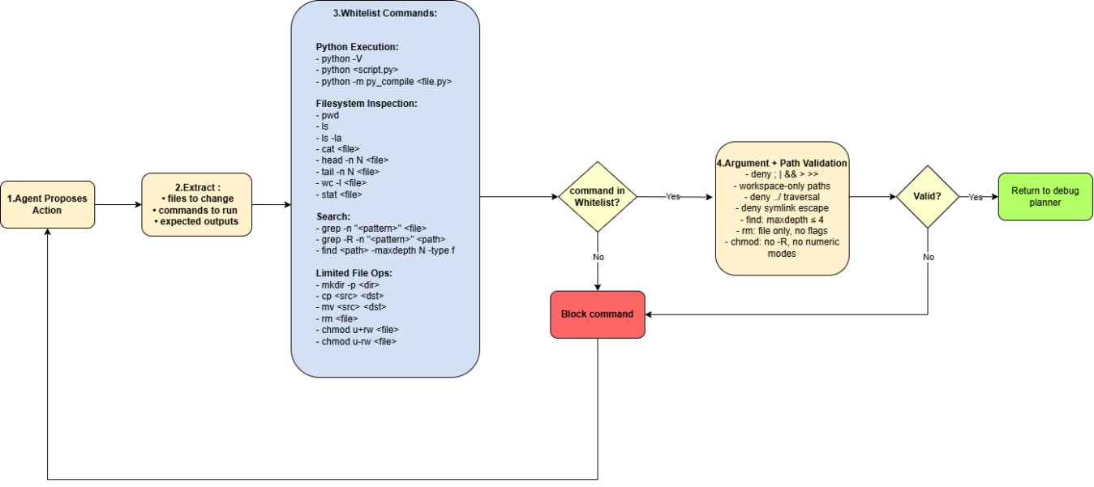

Figure 4: Policy Check and Guardrails Command Validation Workflow.
Python Execution
- python -V
Why allowed:
Verifies the interpreter version to ensure compatibility before execution. It is read-only and does not execute user code.
Risk level: Minimal.
Why safe: Does not modify files or execute scripts.

- python <script.py>
Why allowed:
Core execution mechanism for generated code. The agent must run the script to validate correctness.
Risk level: High (arbitrary code execution).
Why safe under guardrails:
- Script restricted to workspace
- Execution timeout enforced
- No shell invocation
- Optional static analysis before run

- python -m py_compile <file.py>
Why allowed:
Detects syntax errors without executing runtime logic. This allows early validation before full execution.
Risk level: Very low.
Why safe: Only compiles to bytecode; does not execute program logic.

- python -m pytest
Why allowed:
Executes test cases to validate correctness of generated or fixed code.

Risk level: Moderate (executes project code).
Why safe:
- Tests restricted to workspace
- No external test discovery outside project
- Execution timeout enforced

- python -c "<snippet>"
Why allowed:
Used for short diagnostic checks (e.g., verifying imports or environment state).
Risk level: Moderate (executes inline code).
Why safe:
- Limited to single-line diagnostic checks
- No file writes
- No subprocess calls allowed

Filesystem Inspection
- pwd
Why allowed:
Confirms current working directory. Helps verify workspace confinement.
Risk level: None.
Why safe: Read-only environment inspection.

- ls
Why allowed:
Lists files to confirm script creation or directory structure.
Risk level: Low.
Why safe: Restricted to workspace path.

- ls -la
Why allowed:
Provides detailed file metadata (permissions, size, timestamps) for debugging.
Risk level: Low.
Why safe: Read-only operation within workspace.

- cat <file>
Why allowed:
Displays file contents for debugging and error inspection.
Risk level: Moderate (potential data exposure).
Why safe:
- File must be inside workspace
- No access to system files
- No traversal allowed

- head -n N <file>
Why allowed:
Displays first lines of file (useful for checking logs or script headers).
Risk level: Low.
Why safe: Read-only, bounded output.

- tail -n N <file>
Why allowed:
Displays last lines of file (commonly used to inspect error logs).
Risk level: Low.
Why safe: Read-only, bounded output.

- wc -l <file>
Why allowed:
Counts lines to validate file completeness or log size.
Risk level: Very low.
Why safe: Does not expose file content, only metadata.

- stat <file>
Why allowed:
Retrieves metadata (size, permissions, timestamps) useful for debugging.
Risk level: Low.
Why safe: Metadata-only access within workspace.

Search
- grep -n "<pattern>" <file>
Why allowed:
Searches for specific code fragments or error patterns within a file.
Risk level: Low.
Why safe:
- File restricted to workspace
- Read-only operation

- grep -R -n "<pattern>" <path>
Why allowed:
Recursive search across project files to locate broken references or missing imports.
Risk level: Moderate (recursive traversal).
Why safe:
- Path restricted to workspace
- Recursion limited in depth
- No system directories accessible

- find <path> -maxdepth N -type f
Why allowed:
Discovers files within workspace for structured debugging.
Risk level: Moderate.
Why safe:
- maxdepth limited
- No -exec
- No destructive flags

- find <path> -maxdepth N -type d
Why allowed:
Discovers directory structure inside workspace.
Risk level: Low.
Why safe:
- Non-destructive
- Depth limited
- Workspace confined

Limited File Operations
- mkdir -p <dir>
Why allowed:
Creates directories needed for generated code outputs or testing.
Risk level: Low.
Why safe:
- Directory must be inside workspace
- No absolute paths
- No traversal

- cp <src> <dst>
Why allowed:
Used to duplicate scripts before modification or backup broken versions.
Risk level: Moderate (file manipulation).
Why safe:
- Both paths inside workspace
- No recursive flags
- No wildcards

- mv <src> <dst>
Why allowed:
Renames or replaces files during iterative debugging.
Risk level: Moderate.
Why safe:
- Workspace-only paths
- No cross-filesystem moves
- No system files

- rm <file>
Why allowed:
Removes failed generated scripts or temporary files.
Risk level: High (destructive).
Why safe:
- File-only (no directories)
- No -r, no -f
- Workspace-only
- No wildcard expansion

- chmod u+w <file>
Why allowed:
Temporarily grants write permission to modify a generated file.
Risk level: Moderate.
Why safe:
- Only user write bit
- No recursive permission changes
- No numeric modes

- chmod u-w <file>
Why allowed:
Removes write permission to prevent accidental modification after validation.
Risk level: Low.
Why safe:
- Only user-level modification
- No privilege escalation

Required Resources
Resource | Provided By | Cost | Notes
Cloud VM (Ubuntu Linux) | Provided by advisor | Free | For development, testing, and agent execution
LLM API Key | Provided by advisor | Free | Access to LLM inference for reasoning and generation
GitHub Repository | Provided by advisor | Free | Private repository for version control
Python 3.11+ | Pre-installed | Free | Primary development language
Docker | Open source | Free | Container isolation for sandboxed code execution
Ollama | Open source | Free | Local LLM deployment and model management
VSCode | Microsoft | Free | Development IDE

Preliminary implementation
The project has finished Phase 1 (Agent Technology Analysis) and Phase 2 (System Architecture Definition). The implementation is now moving into Phase 3.
Phase 1 Deliverables Completed:
- Market analysis of ten AI coding tools on seven dimensions of comparison.
- LLM benchmarking of eight model variants . ). Qwen3 8B chosen as main model, with Qwen2.5-Coder 7B as backup.
- Risk analysis with six-layer guardrail structure (container isolation, permission management, resource constraints, input validation, monitoring, security modes).
Phase 2 Deliverables Completed:
- Twelve -module pipeline system design with two operational modes (Generate Mode and Debug Mode) and two feedback paths.
- Workflow diagrams created for: AI Agent Workflow, Code Generation Workflow, Code Debugging Workflow, and Policy Check/Guardrails Command Validation Workflow.
Design Alternatives Evaluated:
Three high-level designs were compared (monolithic, IDE-integrated, and standalone CLI). The dual-mode design using the CLI was chosen for local execution without IDE dependencies. At the lower level, a hybrid deterministic/probabilistic strategy was chosen for error classification.
Configuration and Change Management:
A private GitHub repository, Agile sprints, and a cloud VM are established. Both LLM models have been locally deployed using Ollama to test hardware compatibility and inference latency. Subprocess execution with sandboxing, stdout/stderr capture, timeout enforcement, and command whitelisting have been prototyped and tested.
Next Steps:
Phase 3 (Proactive Code Generation) is the immediate priority: Requirement Parser, ReAct Planner, Library Validator, and Code Generator. Phases 4–5 (Self-Correction Loop and Standalone Debugger) follow directly.

Conclusion and Future Work Planning :
In this report, the design of the AI Coding Agent has been introduced, which is an autonomous system using an LLM that is capable of proactive code generation and reactive debugging. The market analysis has shown that there is no existing lightweight tool that is capable of code generation from natural language, executing it locally, and debugging it autonomously without human intervention. The design of the twelve -module system is a solution to this problem. Qwen3 8B, which is executed locally by Ollama, has excellent coding capabilities with complete data isolation.
Methodology for Remaining Phases :
Development is based on Agile sprints. Phase 3 will implement the Generate Mode. Phase 4 will construct the self-correction loop. Phase 5 will formalize Debug Mode. Phase 6 will integrate both modes and test for 10 generation tasks and 10 broken scripts. Phases 7-8 will address packaging, documentation, and final deliverables that is due on May 12, 2026.
Risk Management:
Critical risks: LLM latency going over 60s target values (addressed by quantization/prompt optimization), unreliable error classification for uncommon errors (addressed by hybrid method), infinite debugging loops (addressed by 10-iteration limit and same-error detection), and protection against autonomous execution (addressed by container isolation, command whitelisting, and filesystem constraints). All resources are free of charge.
Project Management and Team Organization:
Four people working remotely with weekly sprints. One person handles the Code Generation pipeline, another the Debugging loop, the third the Guardrails and Policy Check system, and the fourth integrates all components into a single CLI tool. Phases 4-5 (Self-Correction Loop) are a joint effort because they connect code generation and debugging. Phase 6 (Integration/Evaluation) is a team effort.

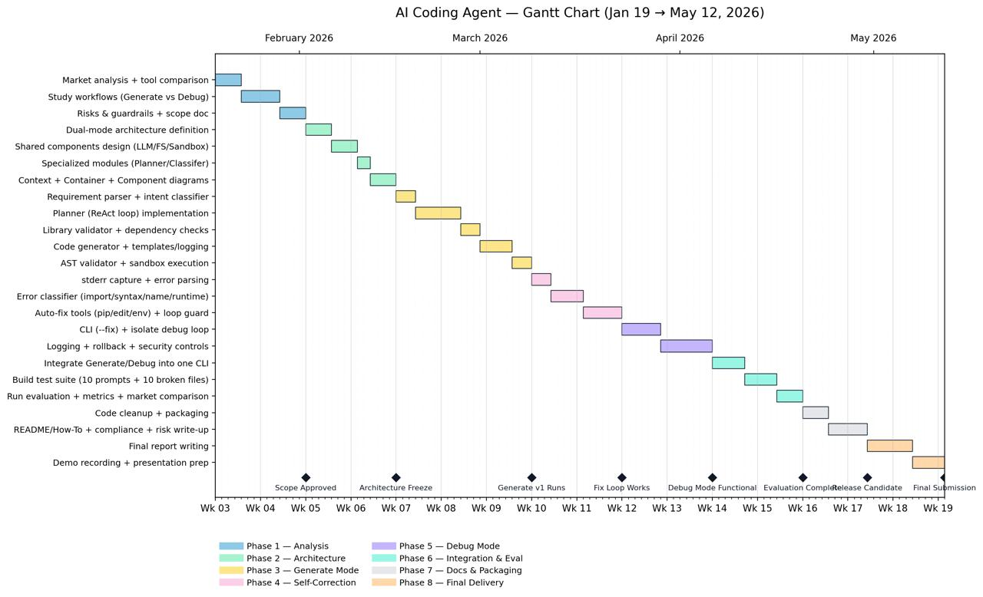
Figure 5: Figure 6 Gantt chart

References

https://github.com/QwenLM
https://toloka.ai/blog/ai-coding-agents-what-they-are-how-they-work-and-how-to-build-one/
https://tweag.github.io/agentic-coding-handbook/WORKFLOW_DEBUG/
https://www.backslash.security/blog/claude-code-security-best-practices
https://github.com/melihmucuk/leash

Statement on the Use of Generative AI
Generative AI tools were used during the development of this project for supportive purposes. Claude was used to help with the writing, language, and structure of the report. All the technical choices in this project were done, checked and approved by the authors. he authors of this project take full responsibility for the content and results of this project.

